Project : Retail_Sales_Analysis
- To fetch top 10 transactions.
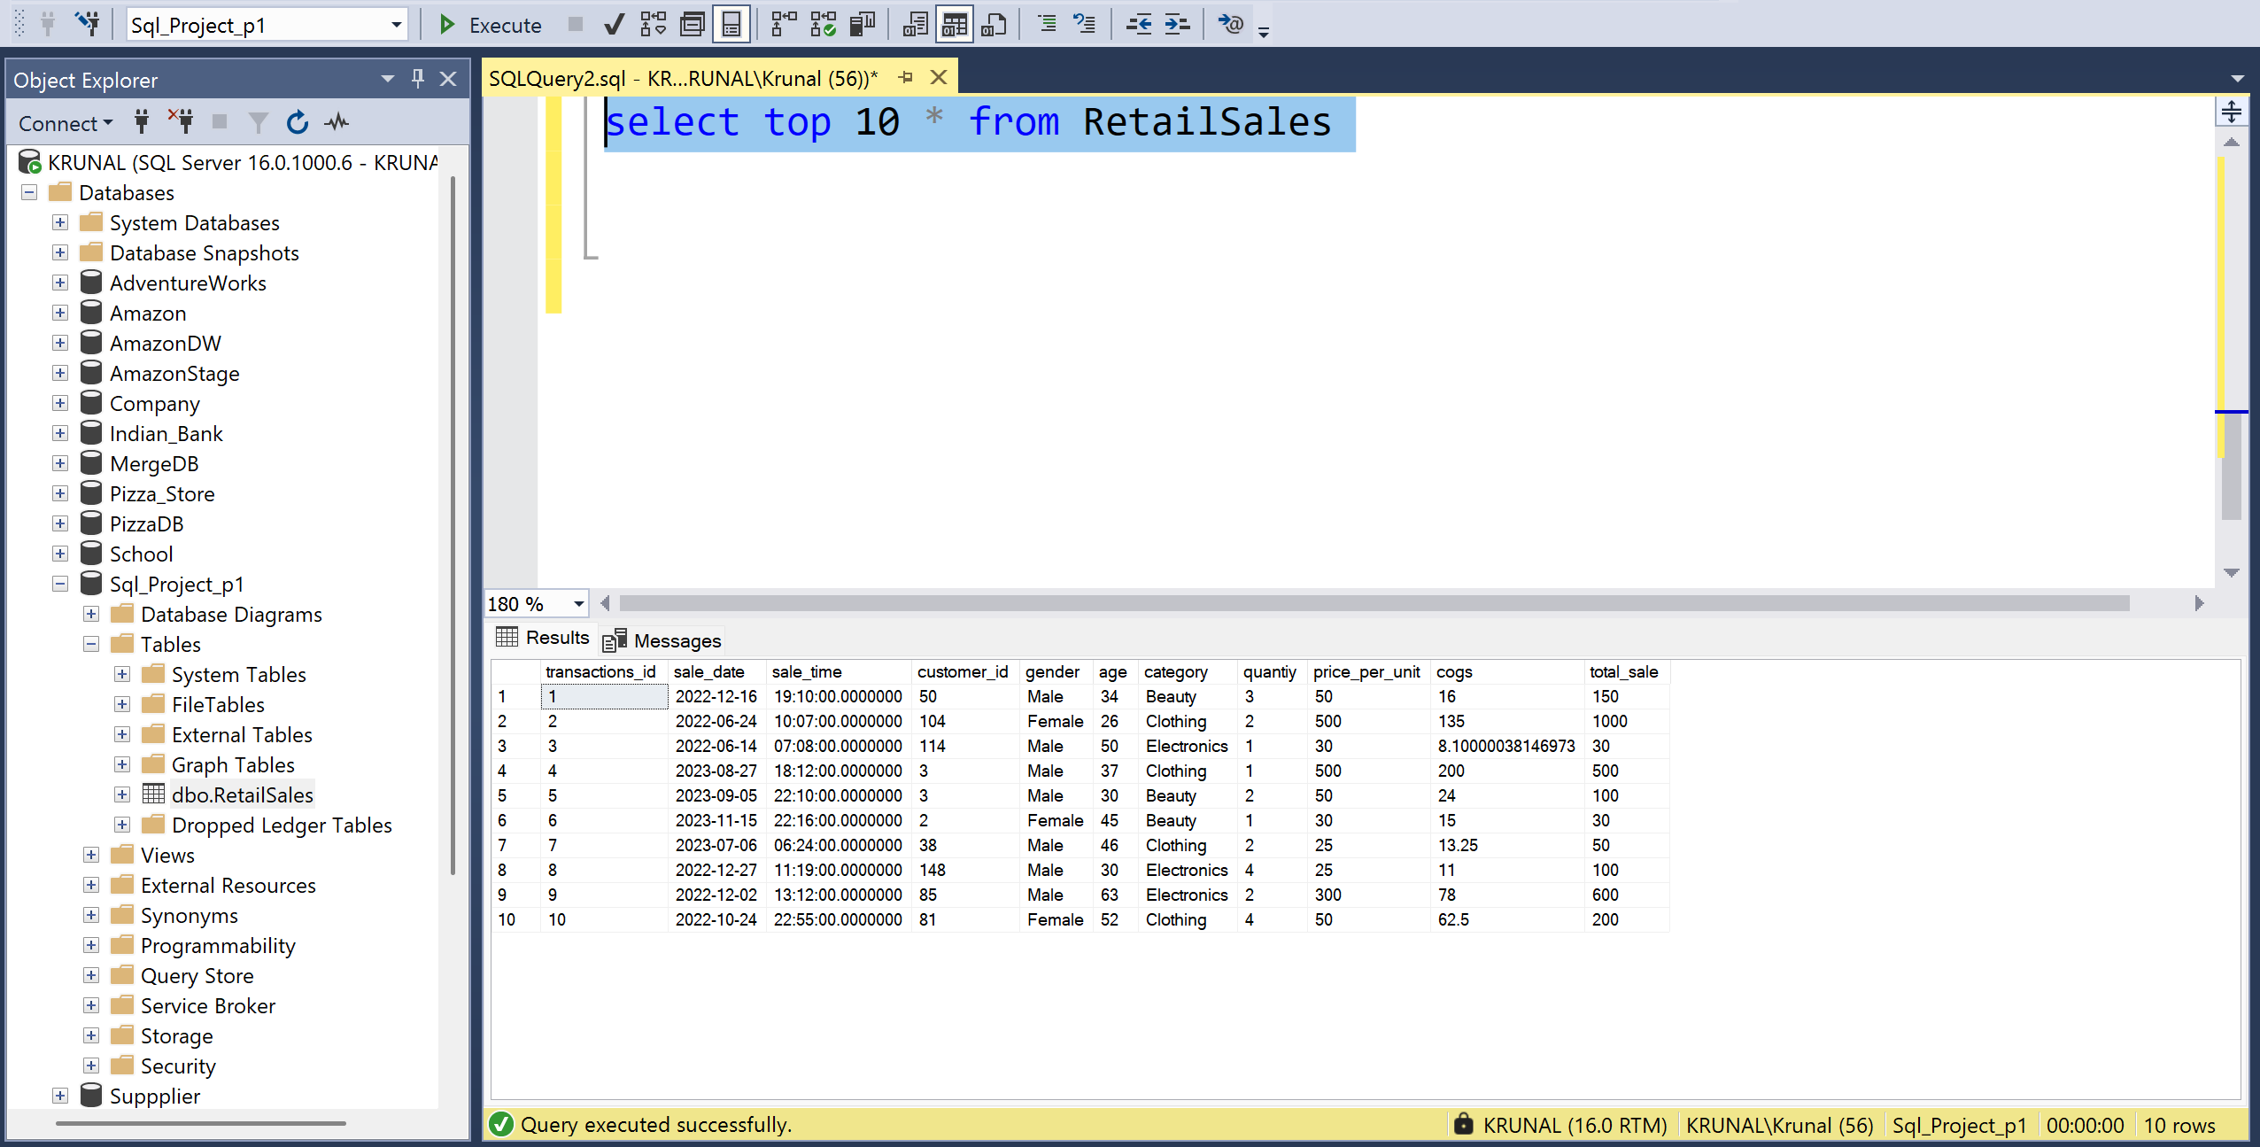
- Look at above shown picture and observe a time column. After running below query I could be able to fix it( refer to picture below)
ALTER TABLE RetailSales
ALTER COLUMN sale_time TIME(0);

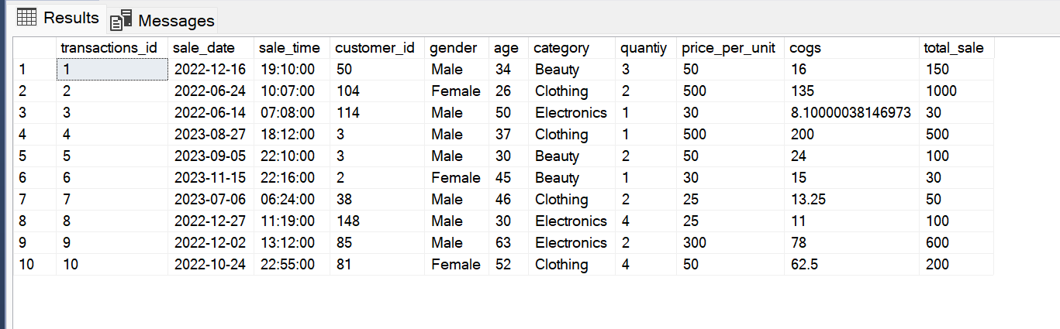

- To verify the total number of rows in the dataset.
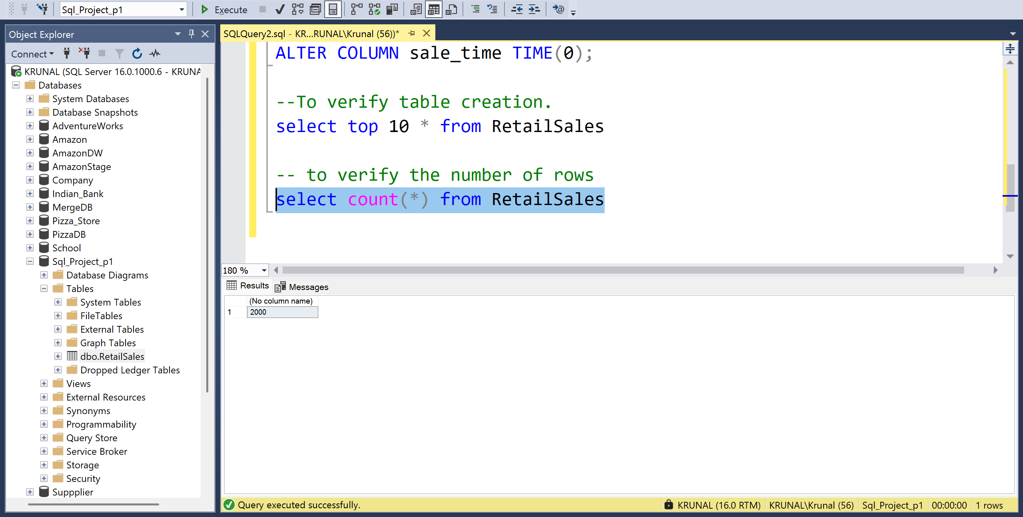

- To find Null values within the dataset
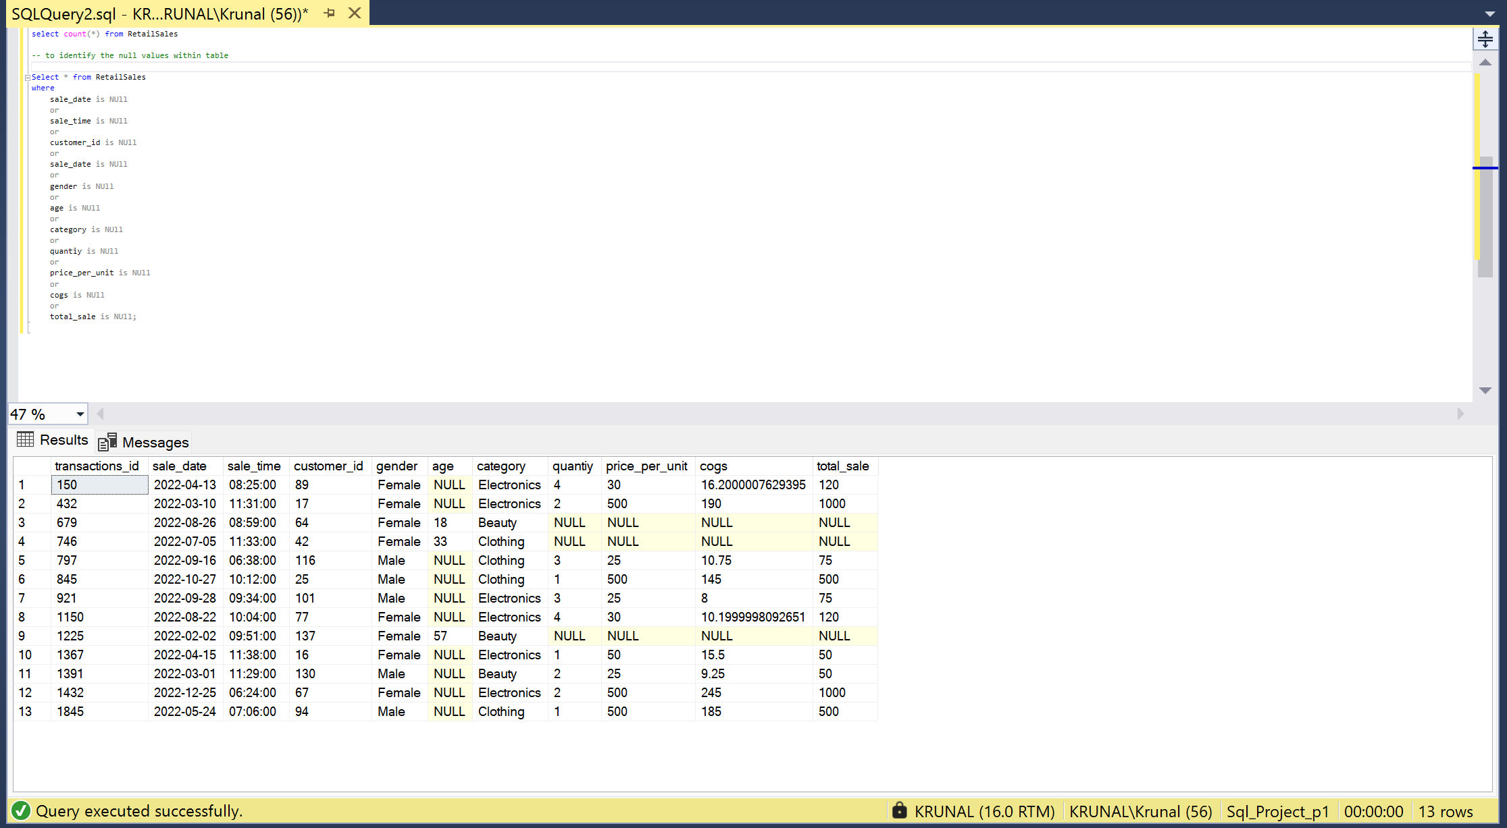

- Now we will be deleting those null values except age.
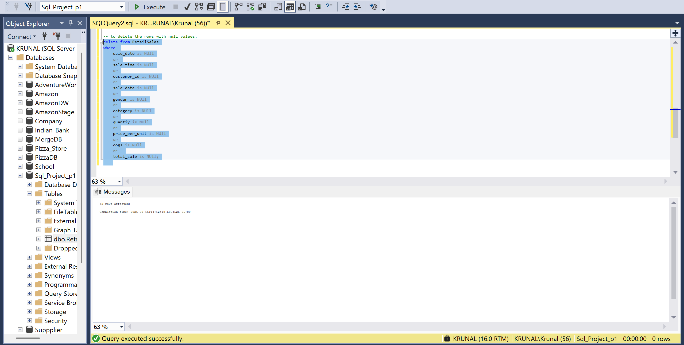

- Data exploration phase.
- Here we will be finding how many sales transactions we have.
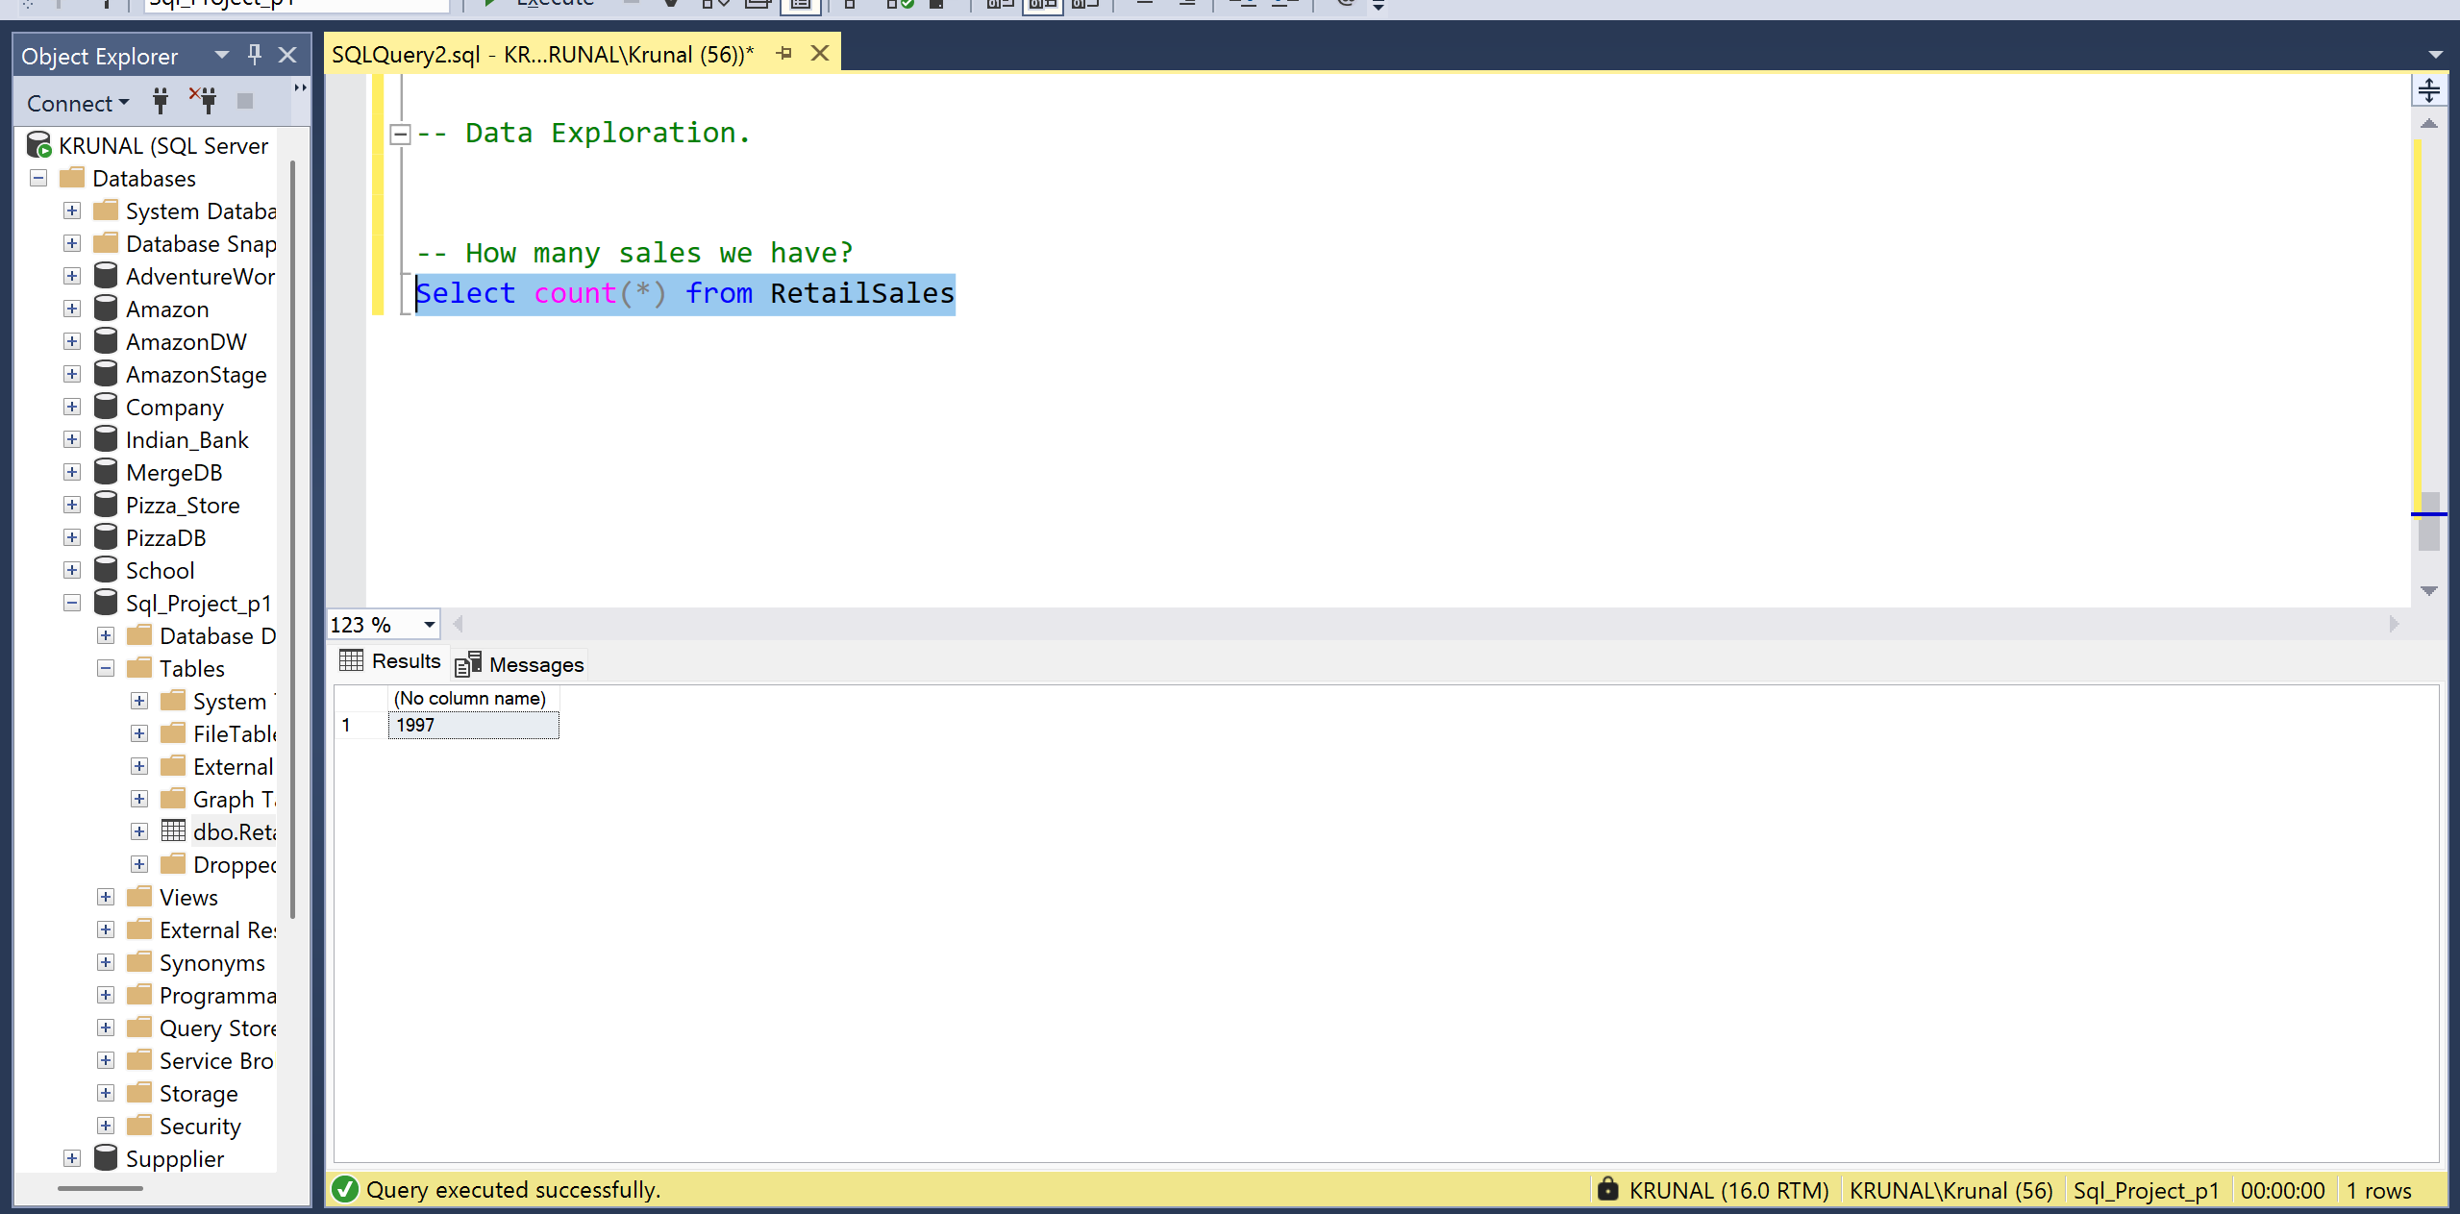

- The number of customers
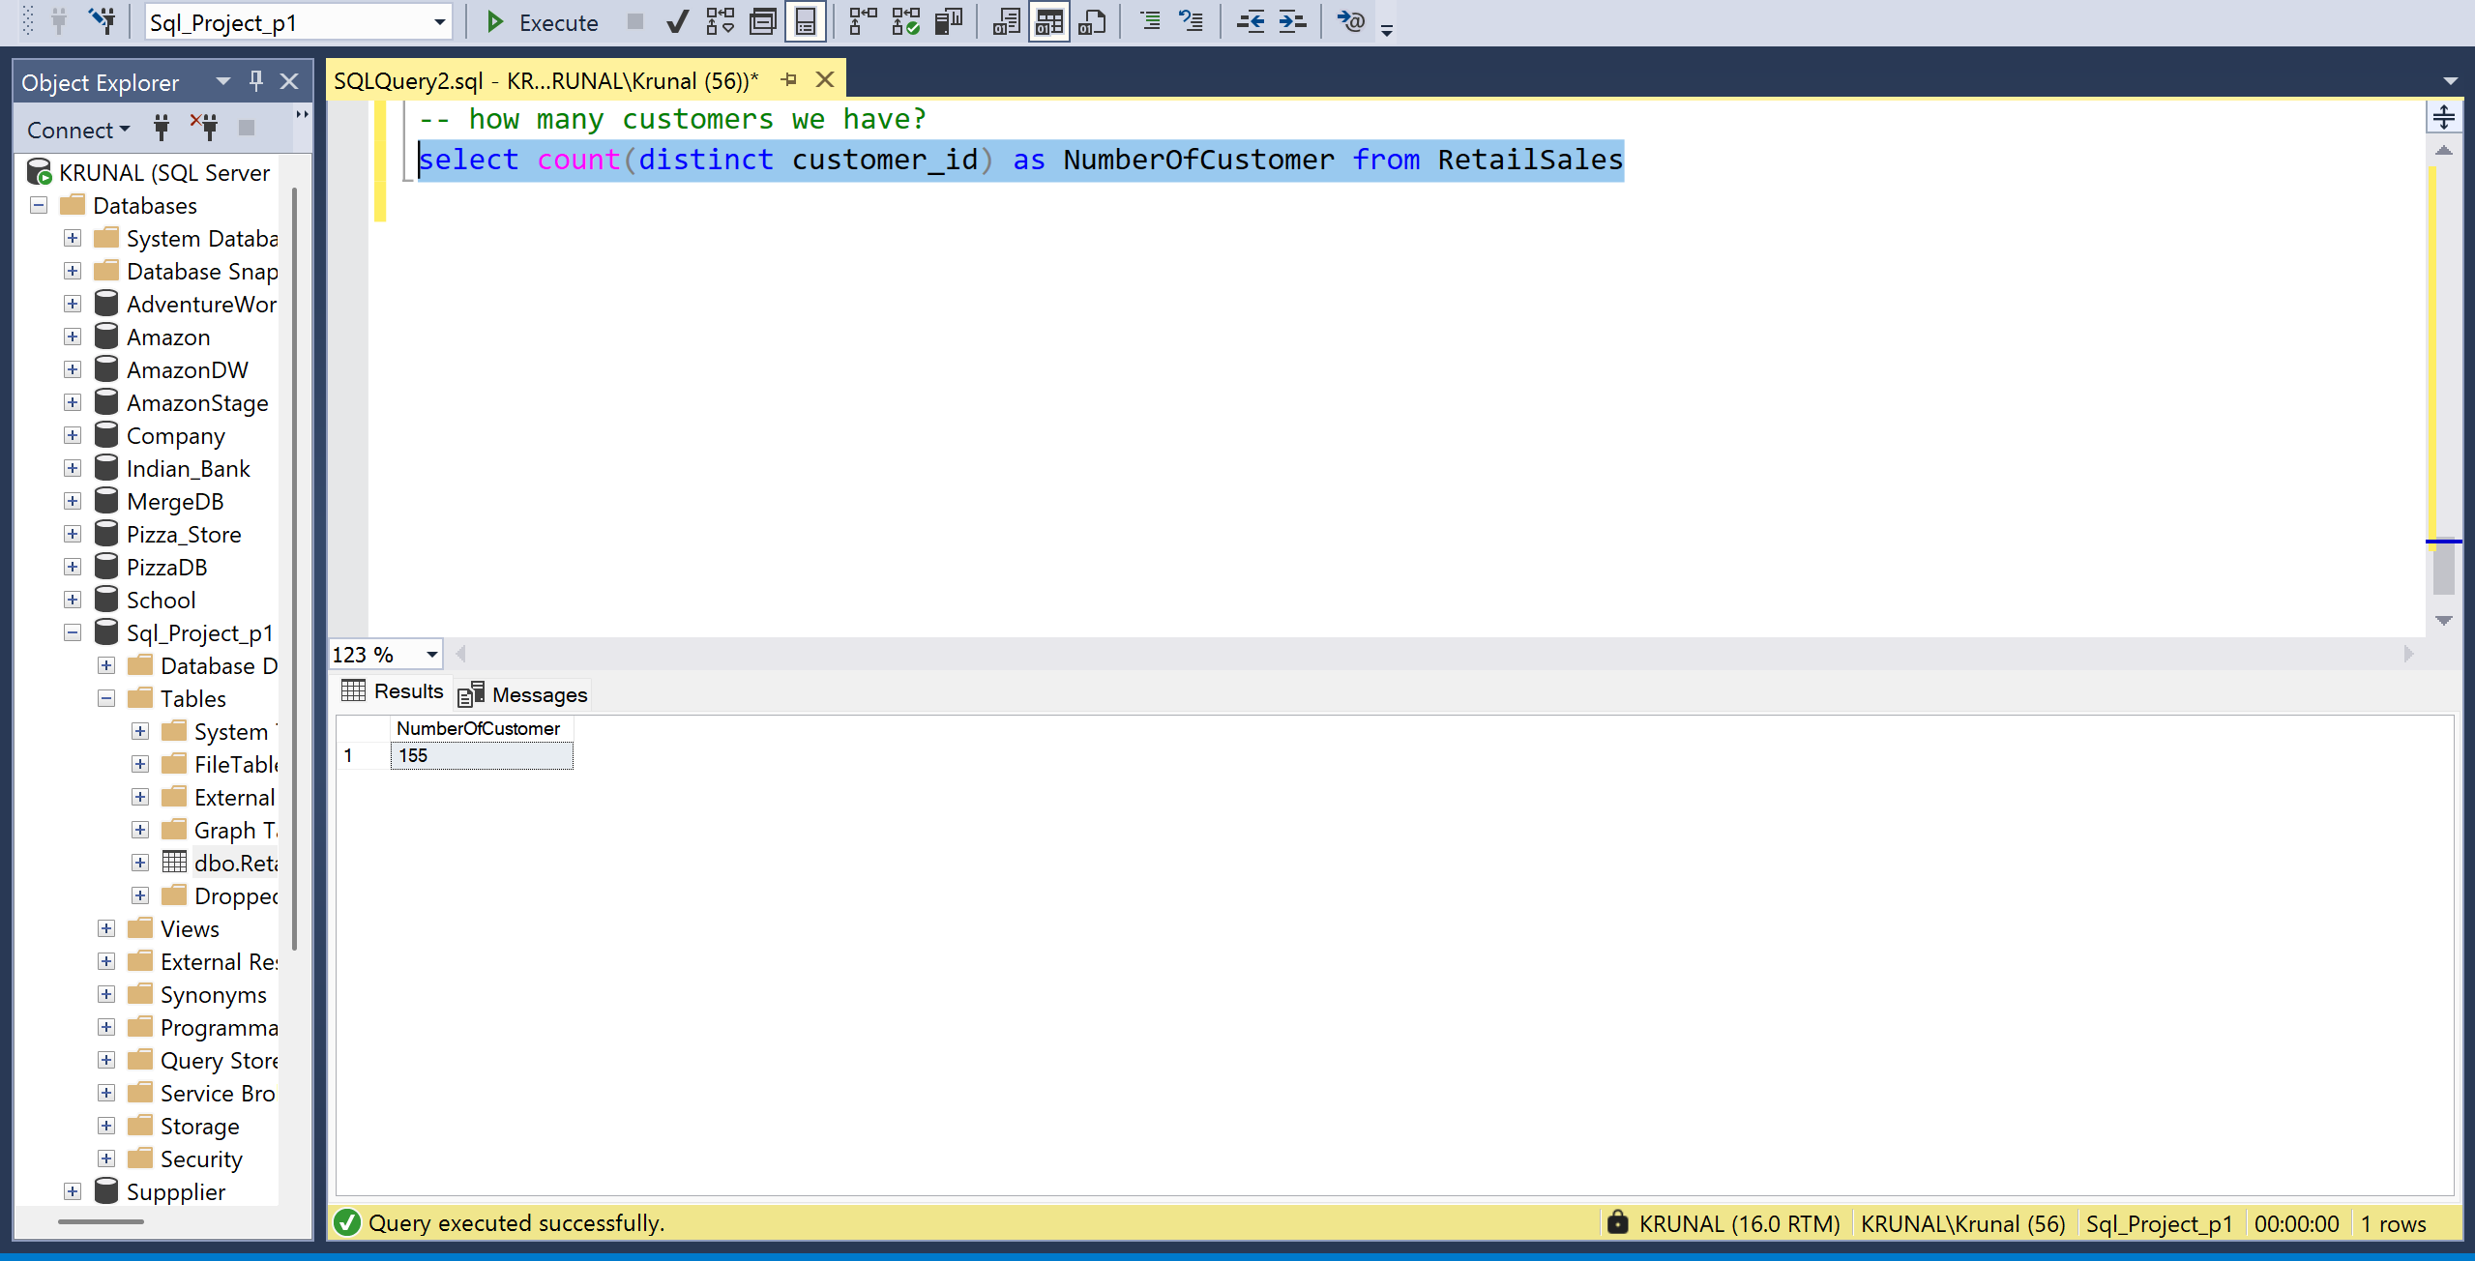

- Total number of UNIQUE Category.
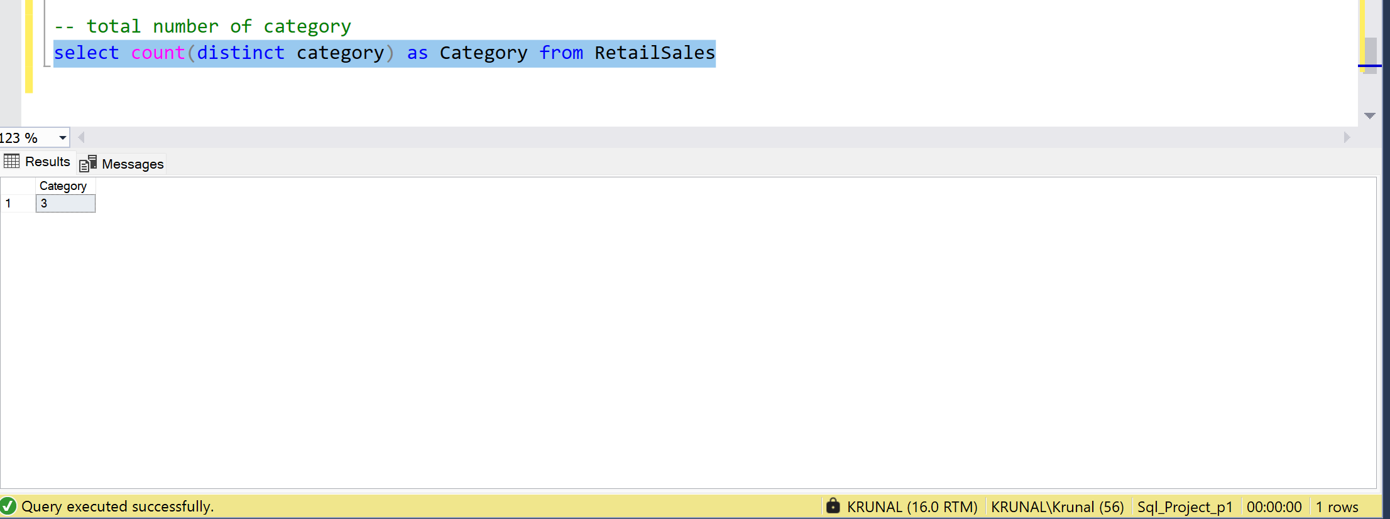
- To get the name of those category
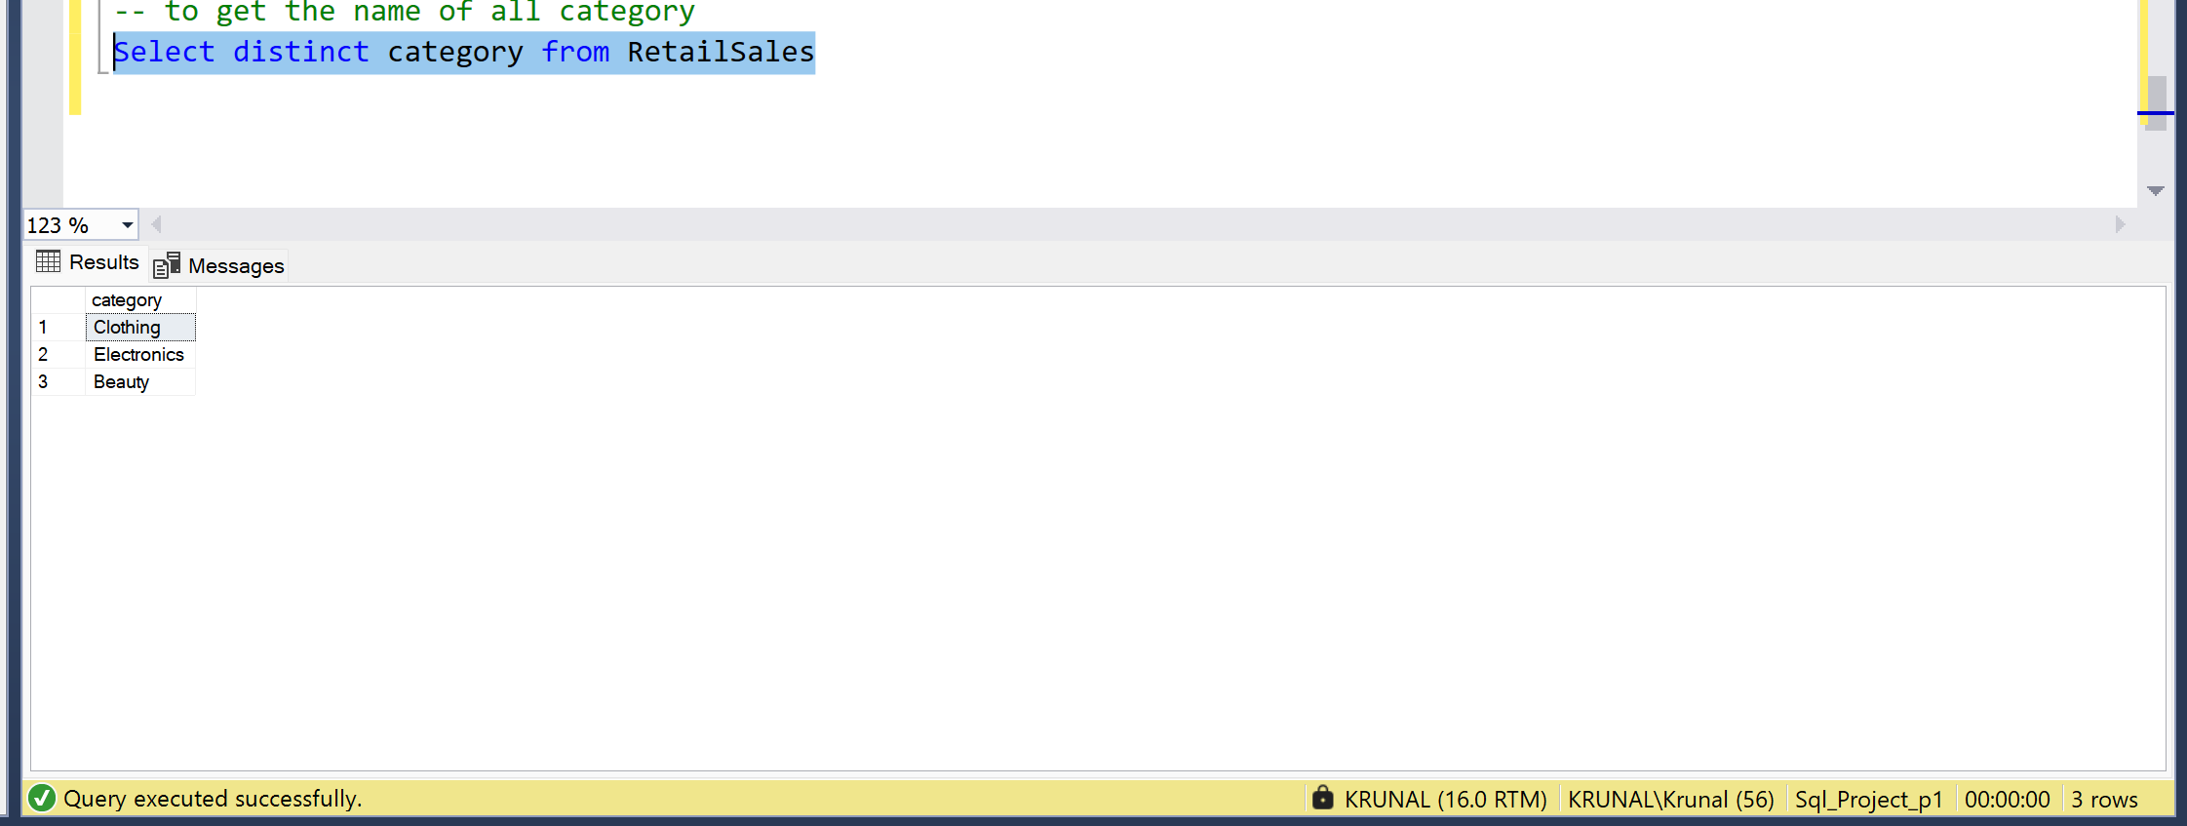
- To find more than 4 quantities of clothing category in the specific month.
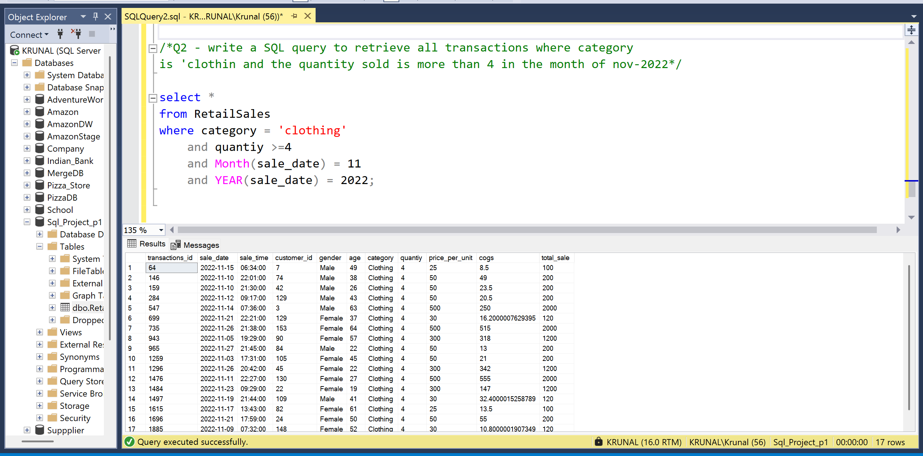
- Sales by category and total orders
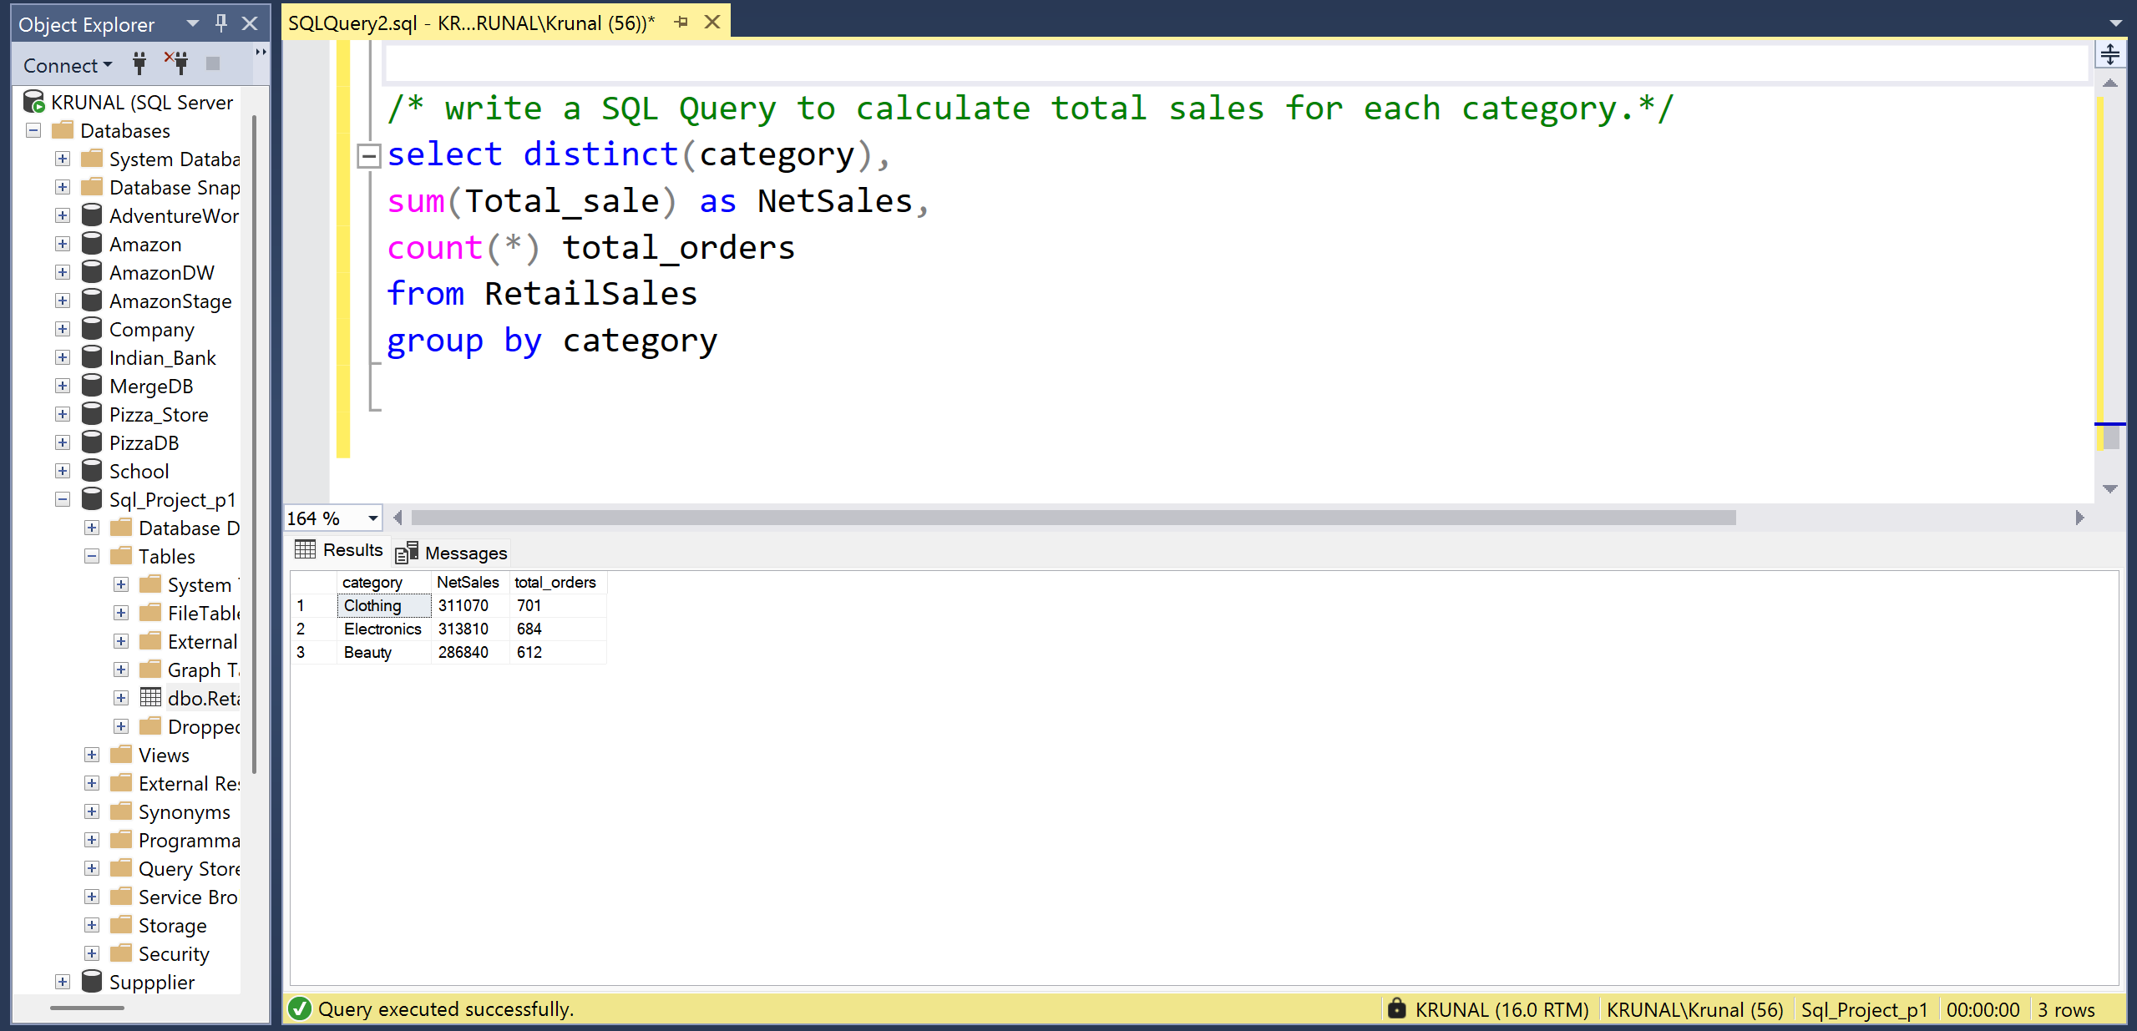

- Average age of buying from particular category.
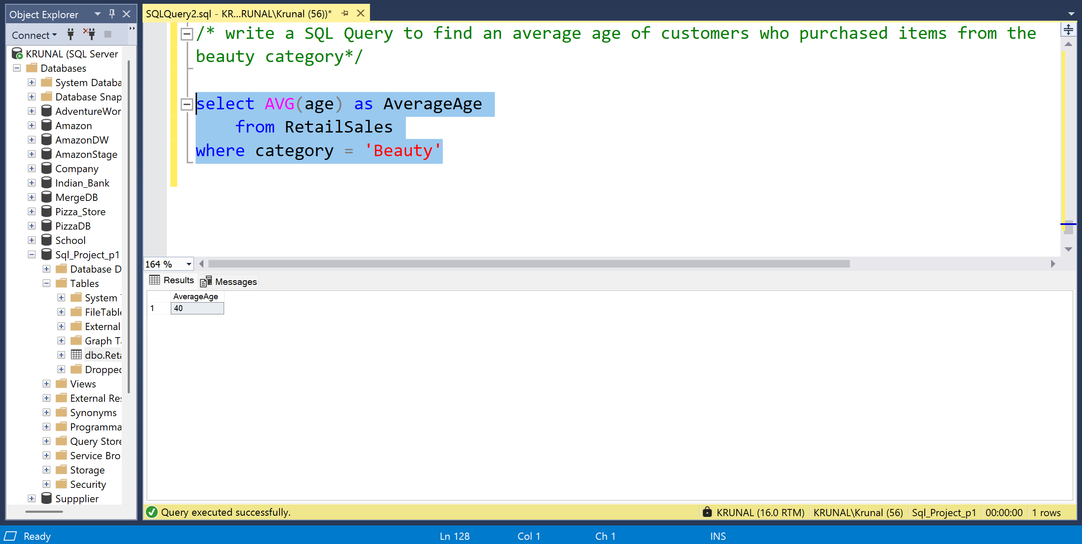
- Total Number of transactions by category and gender
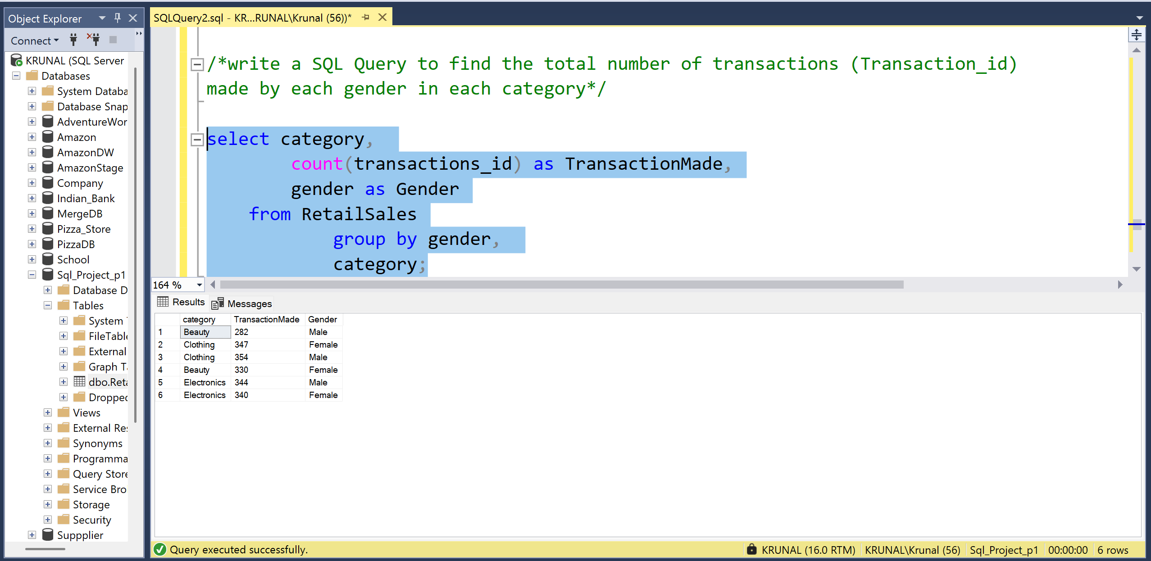

- Write a SQL category to calculate the average sale for each month and finding out best selling month in each year.
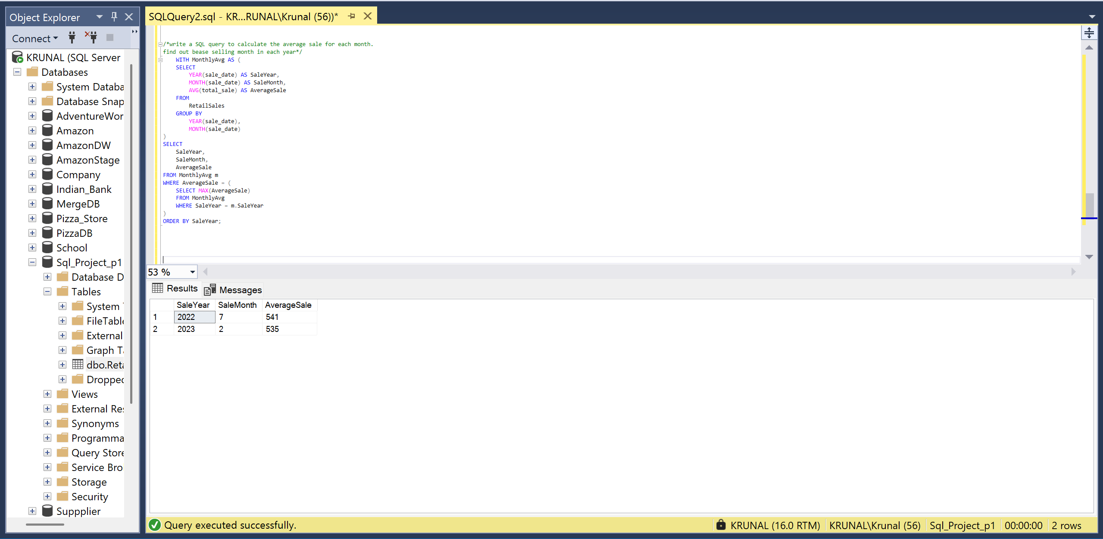
- Write a SQL Query to find the top 5 customers based on the highest total sales.
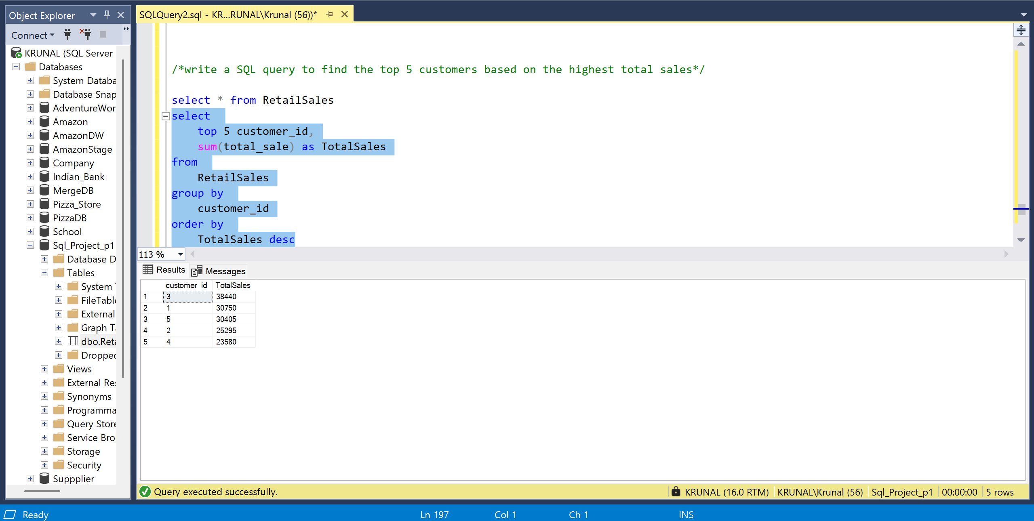

- Total number of customers by each category.
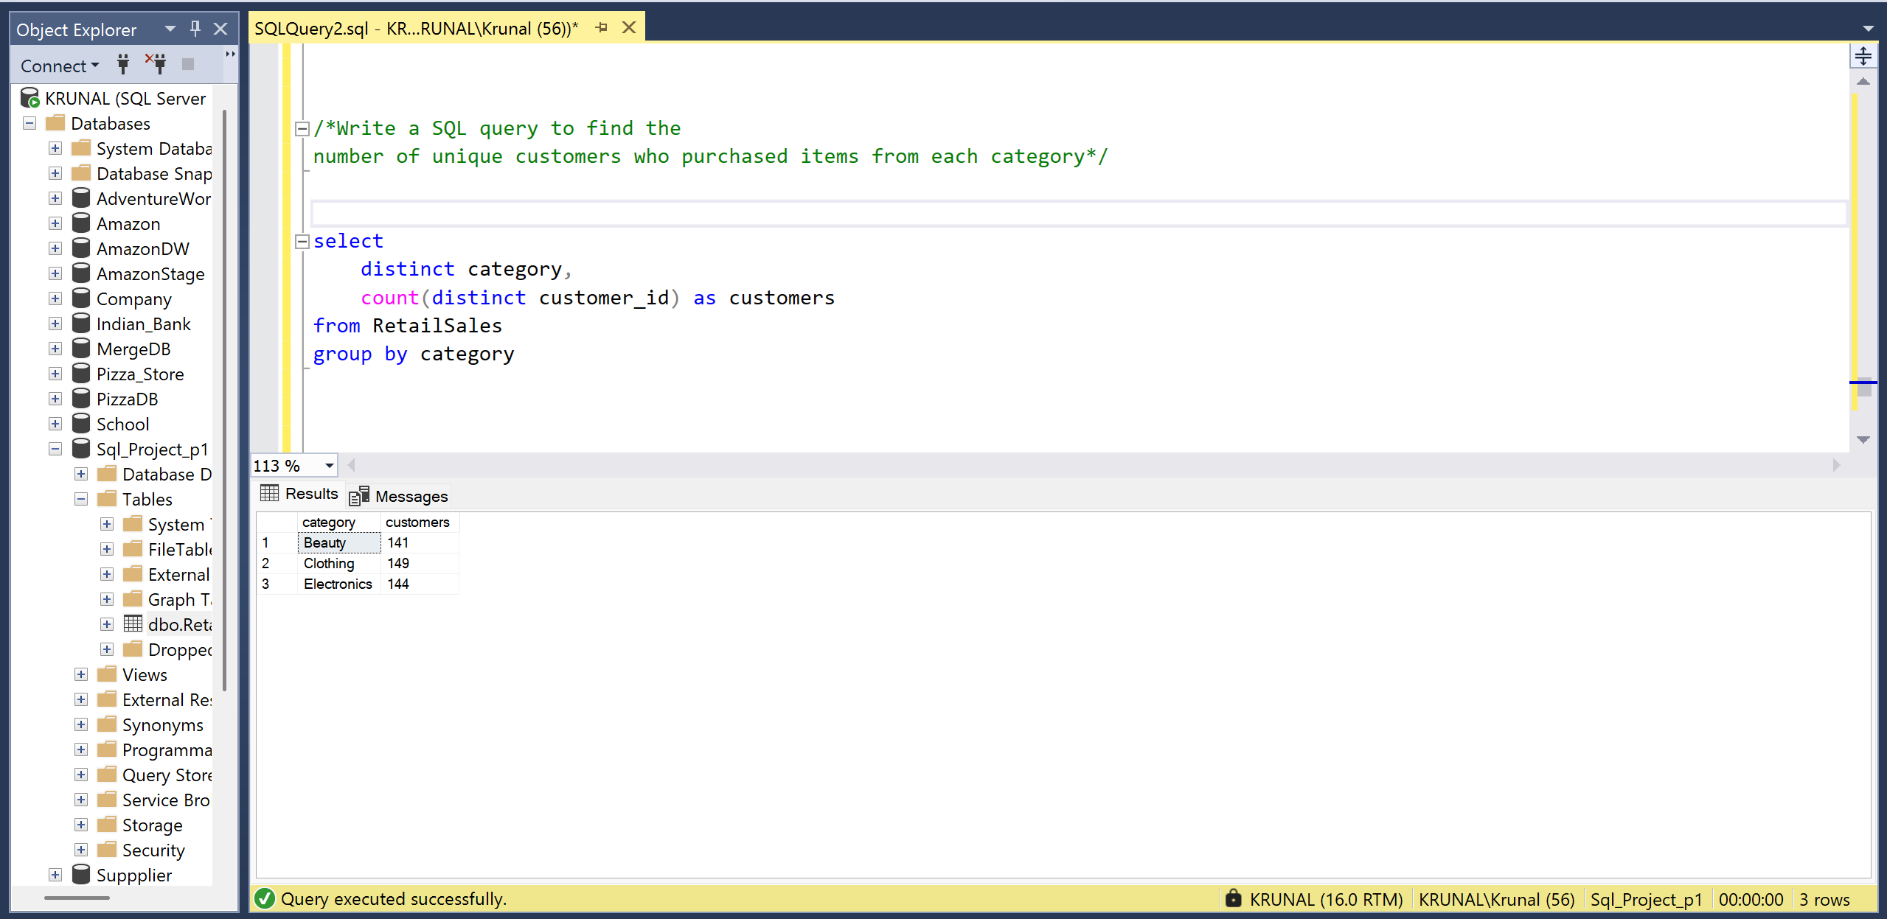
- Shift wise total number of orders.
